BLOOD BANK

The main window: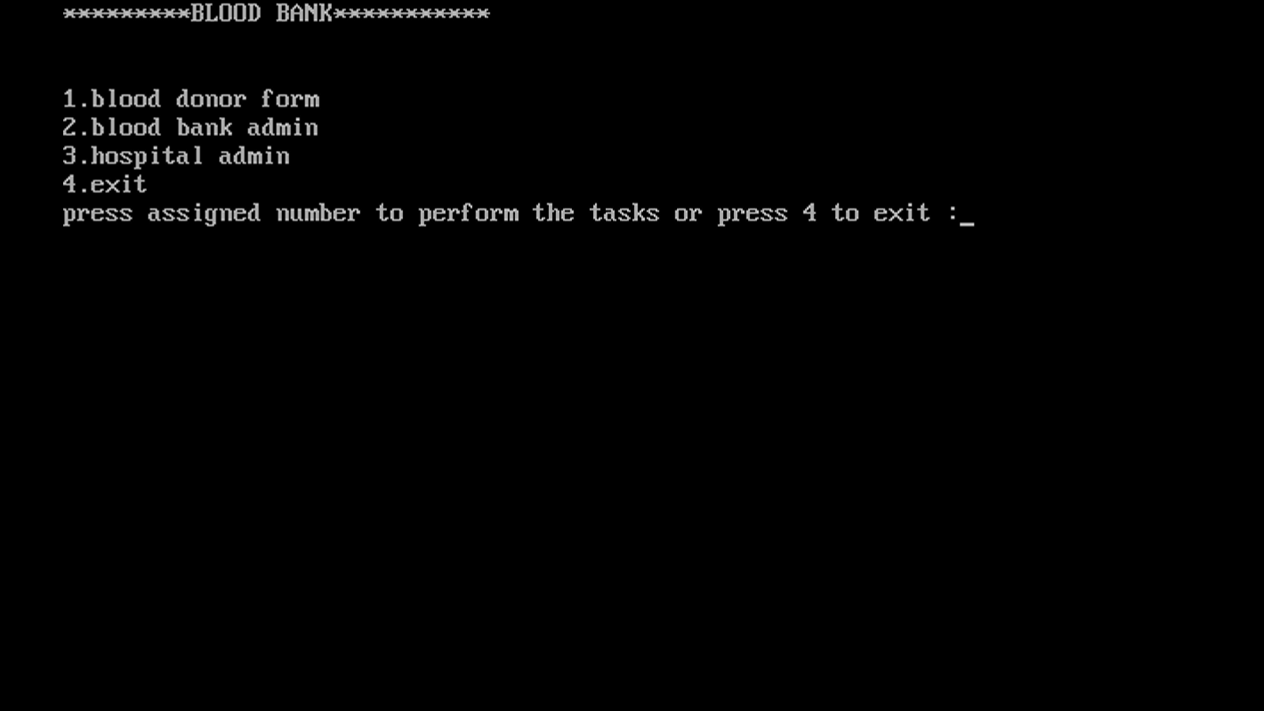

Modules:

1. Blood donor registration form: